KHADIJA ZAHOOR
Graphic Designer

Contact

03434787701
khadijazahoor40@gmail.com Rafaya band road Lahore
Soft Skills
- Creative
- Time Management
- Problem Solver
- Empathic Listener
- Innovative
- Collaborative
- Communicative

Skills
Adobe Illustrator Adobe Photoshop
Canva
Davinci Resolve Capcut
Hey!
I am Khadija, a passionate and creative designer, I am eager to embark on a journey of artistic exploration and growth. I am excited to channel that passion into a valuable learning experience as I believe in the power of continuous learning and growth

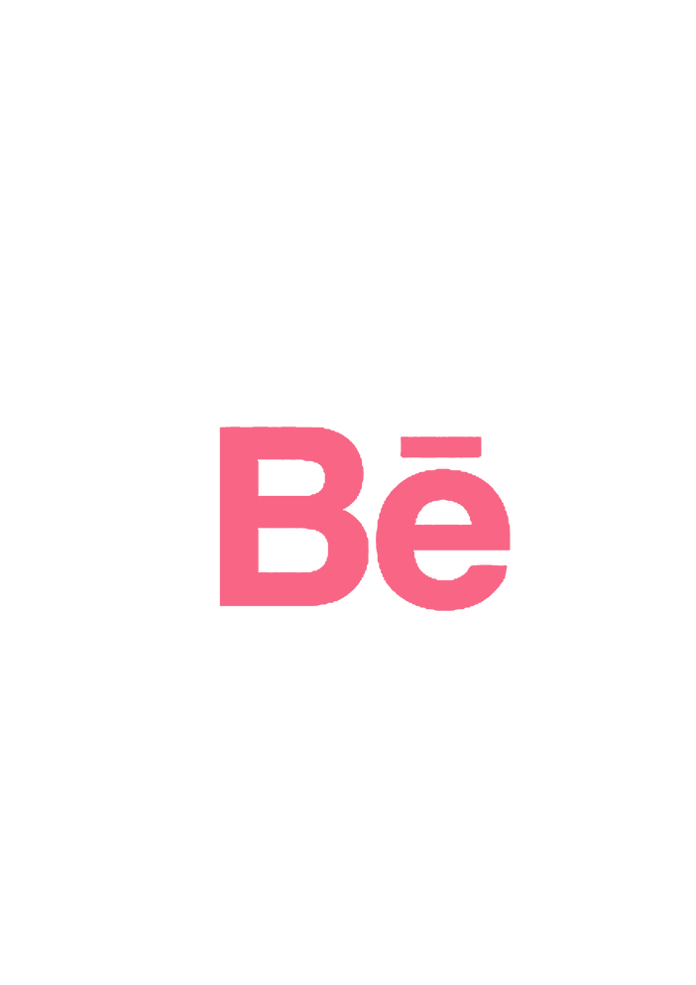
Education

BS in Applied Psychology
Punjab University 2020-2024
Fsc Pre Medical Punjab College
2018-2020

Matric
Govt. Girls High School
2016-2018
Graphic Design Course
Digital Skills Center 2025

Portfolio
https://www.behance.net/khadijadesigner23

